**Tourism Data Exploration: Analysis and Visualization for Impactful Insights**

Vaishnavi C 1, Shruthi V 2, Ruthika S Shetty 3, Sreelatha PK 4

1, 2, 3 Department of Computer Science and Engineering, Presidency University, Bengaluru, India

4 Assistant Professor, Department of Computer Science and Engineering, Presidency University, Bengaluru, India

***Abstract:*** Tourism happens to be a dynamic and fast-evolving sector, which is largely significant to economic development and cultural exchange. The proposal aims at improving the Indian tourism industry with an application of Artificial Intelligence and Machine Learning (AIML) techniques, providing insights and solutions to the industry through an analysis of varied datasets concerning Indian tourism-clustering, predictive modelling, and trend analysis to find useful patterns and insights within travel behaviour, regional performance, and socio-economic impacts.  
Clustering models assign clusters of tourist spots on aspects such as geographic characteristics, popularity, and preferences of visitors to create possible configurations of travel options. Predictive models predict the travel patterns with which tourism authorities plan their domestic circuit tours and better allocation of resources. This proposal will specify seasonal trends through historical and demographic data analyses and preferences that are region-specific to enable stakeholders to promote sustainable tourism practices.  
Advanced algorithms like K-Means clustering include data pre-processing, exploratory analysis, and generation of interactive data visualizations to drive insightful decision-making. Such results include identification of highly-rated landmarks, overcrowded tourist destinations, and performance statistics on tourism for regions, which are necessary for the right managing of the marketing strategy, planning of infrastructure, and optimization of resources.  
This proposal builds a comprehensive framework with AI/ML-driven technique-based approaches alongside holistic datasets toward thinking about and acting in the complex world of the tourism ecosystem, which also points to the transformational power of data-driven decision-making toward a sustainable future.

***Keywords—Tourism; Clustering; Predictive Modelling; Sustainable Tourism; K-Means; Travel Behaviour; Demographic Analysis; Trend Analysis; Data Visualization; Regional Tourism Performance; Resource Optimization; Covid-19.***

1. **INTRODUCTION**

Tourism contributes a lot to world economy and the sharing of cultures on the global front; India with her unique attractive sites gets a lot of visitor ships. Nevertheless, issues such as overcrowding, demand variability and distribution of resources need sophisticated solutions. This proposal incorporates the utilization of both AI as well as ML on the Indian tourism data sets with a view of making recommendations.

Complex models classify tourist destinations by certain criteria, including level of demand, geographical location, and tourist’s preferences, thus helping to apply targeted promotion and infrastructure development. Decision trees for instance Random Forest help in the prediction of happenings such as movement of people and therefore aid in arrangements for resource provision and the creation of tour packages. Socio-temporal factors are explored for the adoption of appropriate measures in ecological tourism.

Data cleaning, feature extraction and exploration, K-Means clustering with PCA visualisation and trend analysis were among the methods used. Examples are determining famous tourist attractions and poor-performing areas so that stakeholders can utilize intelligence on the development of an efficient, resilient tourist sector.

1. **LITERATURE SURVEY**

The study by Jiantao Wu et al [1] explores the impact of climate change on the tourism economy, a topic not yet fully realized despite increasing climate concerns. Using knowledge graph techniques, including weather data, the study aims to deepen understanding of the relationship between climate and tourism. Findings suggest that organizing climate and tourism data through knowledge graphs can provide valuable insights, potentially enhancing both quality of life and the resilience of the tourism industry. Method includes importing CSV datasets into a Neo4j knowledge graph (KG) using Cypher’s load CSV command. Entities like "Airport" and relationships between "City" and "Weather Station" were mapped, with intermediate CSV files linking "Station" IDs to city names. Key properties, such as geodesic distances, were added to enhance data utility and calculation efficiency within the KG. The data was collected from various resources like NOAA GHCND, AviationStack, Climateq, Simplemaps.

This study by Olimpia Alcaraz et al [2] investigates the intersection of physical and digital realms in tourism, introducing smart tourism destinations (STDs) that leverage technology and open data to enhance visitor experiences and inform decision-making. It demonstrates how integrating open data with local business campaign data can innovate tourism management and foster smart ecosystems through public-private collaboration. An AI based search engine using word embeddings was developed to identify relevant open data, improving traditional data retrieval. The findings highlight the potential of this integration to enrich tourist experiences and support destination management strategies, contributing insights on combining retail and open data in a real case study. The initial internal data used in this study are derived from local campaigns known as bono consumo (consumer voucher), a promotional campaign resulting from the health crisis caused by COVID-19. The initial private dataset was compiled by APYMECO, the local traders’ association, which gathered data on the usage of consumer vouchers in the four editions of the campaign: October 2021, June 2022, September 2022, and November 2022. This dataset comprises more than 300,000 entries.

This paper by Saman Forouzandeh et al [3] introduces a novel approach to travel recommendation systems in the tourism industry, combining the Artificial Bee Colony (ABC) algorithm with Fuzzy TOPSIS. The Techniques for Order of Preference by Similarity to Ideal Solution (TOPSIS) is utilized as a multi-criteria decision-making method to optimize recommendations. Data were collected through an online questionnaire from 1,015 respondents on Facebook. In the first stage, the TOPSIS model identifies a positive ideal solution based on four key factors. In the second stage, the ABC algorithm searches for destinations to recommend the best tourist spot to users, enhancing the decision-making process for tourists. The data was gathered through questionnaires provided to self-driven travellers. The authors distributed a survey to hotel visitors to gather data on the level of service. The data gathered by questionnaires, the exploration of popular topics, and the difficulty of materials were valued.

This paper by Tao Peng et al [4] aims to enhance tourism demand forecasting accuracy by integrating social network data with traditional data sources. Using a web crawler, the authors collect social network data and apply sentiment analysis using the BERT model. The study builds a forecasting model based on Gradient Boosting Regression Trees, incorporating structured variables such as weather and holidays. Using Huang Shan as a case study, the authors conduct an empirical analysis comparing the model's performance against existing models, supported by an ablation study. Results indicate that incorporating social network data significantly improves forecasting accuracy for tourism demand. Social network data acquisition is mainly achieved through web crawlers, which can collect and organize data on the Internet in accordance with established rules.

This study by İbrahim Topal and Muhammed Kürşad Uçar [5] explores the growing importance of the tourism and travel sector in the global economy, emphasizing the influence of social media on consumer purchasing decisions. By analysing historical user data from TripAdvisor, the research aims to employ artificial intelligence methods to identify profiles of consumers likely to prefer Turkey as a travel destination. This approach enables businesses to target the right audience and enhance the effectiveness of their promotional activities. Methods like F-Score Feature Selection Algorithm, classifiers such as Decision trees (DT), k Nearest Neighbours Classification Algorithm (KNN), Multilayer Feedforward Artificial Neural Networks (MLFFNN), Probabilistic Neural Networks (PNN), and Support Vector Machines (SVMs) were used. The study used the travel data history of Chinese tourists taken from TripAdvisor. The data belong to a total of 624 users. The acquisition of historical data took place between 27 April and 11 May 2018.

Nesreen K. Ahmed et al [6] used models like MLP (Multilayer Perceptron) for classification/regression, RBF (Radial Basis Function) with Gaussian functions, GRNN (Generalized Regression Neural Network) using a Gaussian kernel, KNN (K-Nearest Neighbours) based on nearest neighbours, CART (Classification and Regression Trees) with decision trees, SVR (Support Vector Regression) using support vectors, and GP (Gaussian Processes) modelling data as a Gaussian process. This study explores machine learning methods for tourism demand forecasting, traditionally dominated by models like ARIMA and exponential smoothing. It evaluates the performance of seven machine learning models on Hong Kong’s inbound travel data and examines the impact of adding the time index as an input variable, comparing these models' effectiveness against conventional approaches. In this study, data published in the study made by Law and Pine to forecast inbound travel demand for Hong Kong was used.

The study by Ram Krishn Mishra et al [7] shows the use of SVR and Random Forest Regressor. SVR (Support Vector Regression), adapted from Support Vector Machines, is used for predicting real-number data, offering infinite possible solutions for continuous outputs. Random Forest Regressor is a tree-based model that splits data into nodes, with predictions made by averaging responses in terminal nodes for regression tasks. It improves prediction accuracy and reduces overfitting by constructing multiple decision trees on different sub-samples of the dataset, making it more robust than a single decision tree, which is prone to overfitting due to random noise. This study examines international tourist data from 2010 to 2020, analysing multiple dimensions to identify valuable features for forecasting. Using Support Vector Regression (SVR) and Random Forest Regression (RFR), the research predicts global tourist arrivals, achieving forecasting accuracies of 99.4% and 84.7%, respectively. The study also addresses the impact of COVID-19 lockdowns on forecasting accuracy. A substantial amount of data gathered by the government or other public entities is made available. These data sets are referred to as public data since they do not require specific authorization to use them.

The study by Noelyn M. De Jesus et al [8] used time series data of tourist arrivals, particularly around the COVID-19 pandemic, splitting the dataset into three partitions for model training and testing. These partitions were based on key events like the first COVID-19 case (January 2020), travel suspensions (March 2020), and stricter entry restrictions (December 2020). The dataset was loaded into the Orange Data Mining tool, and a Multilayer Perceptron (MLP) neural network was used for time series prediction. The model’s performance was evaluated using metrics like MSE, RMSE, MAE, MAPE, and R². The best model was selected based on the highest R² and lowest MAPE, indicating how well the predictions matched the actual values. This research evaluates the predictive power of an artificial neural network (ANN) model for forecasting tourist arrivals, using tourism data from the Philippines spanning 2008- 2022. The ANN was trained on three distinct data compositions and assessed with various time series evaluation metrics, achieving an R-squared value of 0.926 and a MAPE of 13.9%. The study found that including data from unexpected events, like the COVID-19 pandemic, improved model accuracy. The findings suggest that ANN can be a valuable tool for government and tourism stakeholders to support strategic and investment decisions. The researchers collected the actual inbound tourist arrivals to Philippines between 2008-2022 from the Department of Tourism’s official website.

This article reviews machine learning techniques for predicting tourism, specifically analysing prior studies in this domain. Bilal Sultan Abdualgalil et al [9] discuss various machine learning techniques applied to tourism data analysis, focusing on two primary activities: association learning and classification learning. Key techniques include Logistic Regression and Linear Regression for predicting binary and continuous outcomes, respectively; Decision Trees and Random Forests for supervised classification and regression; Support Vector Machines for binary classification; and Naive Bayes for fast and effective classification. Additionally, KNN is highlighted for its simplicity in classifying data based on nearest neighbours, while K-Means Clustering is used for unsupervised grouping of data. Other methods like Dimensionality Reduction (e.g., PCA) simplify datasets, and Gradient Boosting and AdaBoost improve model accuracy through iterative refinement. The results showed higher prediction accuracy when using the first-quarter dataset, demonstrating its effectiveness for forecasting tourist numbers. The dataset obtained from www.kaggel.com website was used.

This study by Dinda Thalia Andariesta et al [10] presents machine learning models for predicting international tourist arrivals in Indonesia during the COVID-19 pandemic using multisource Internet data. In this study, data from the Indonesian Statistical Bureau, TripAdvisor, and Google Trends were used to develop prediction models for international tourist arrivals. The process involved data pre-processing, feature extraction, and forecasting model development using ANN, SVR, and Random Forest. These models were evaluated using RMSE, MAE, and MAPE to ensure accuracy. The ANN model used previous tourist data, online posts, and search volumes as predictors. The RF model, known for its reliability, averaged predictions from multiple decision trees to improve forecasting performance. First, the researchers collected tourism data from the Indonesian Statistical Bureau Indonesia or BPS from January 2017 until June 2021. Next, we collect the data from a global online tourism platform, TripAdvisor.

1. **METHODOLOGY**

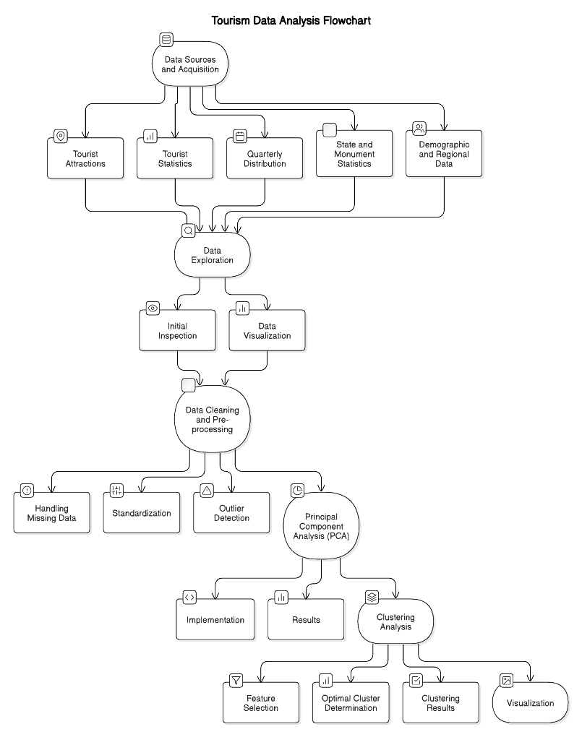This study employs a structured and data-centric approach to analyse Indian tourism dynamics using advanced data processing techniques, dimensionality reduction through Principal Component Analysis (PCA), and clustering algorithms to uncover hidden patterns and groupings. The methodology is segmented into data acquisition, pre**-**processing, analysis, dimensionality reduction, clustering, and visualization phases.

**Fig. 1 - Structured tourism data analysis**

Figure 1 illustrates the data analysis process of tourism, beginning with data collection from various sources and exploration through inspection and visualization. It proceeds with data cleaning, including handling missing data, standardization, and dimensionality reduction using PCA. Clustering analysis is then performed to identify patterns through feature selection and optimal cluster determination. Finally, the results are visualized to derive actionable insights.

**I. Data Sources and Acquisition**

The datasets used in this study are drawn from diverse sources, providing a holistic view of Indian tourism. Key datasets include:

**a. Tourist Attractions:** Data on 325 tourist attractions across India, detailing their locations, types,

historical significance, entrance fees, and visitor ratings.

**b. Tourist Statistics (1981–2020):** Yearly statistics on Foreign Tourist Arrivals (FTAs), Domestic Tourist Visits (DTVs), and associated demographic details.

**c. Quarterly Distribution and Purpose of Visit:** Data on tourist flows by seasons and motivations (e.g., leisure, business).

**d. State and Monument Statistics:** Comprehensive data on state-wise tourist numbers and specific monument popularity in 2019 and 2020.

**e. Demographic and Regional Data:** Information on visitor age groups, regional contributions to tourism, and pandemic-related trends.

**II. Data Exploration**

The datasets were first explored to understand their structure and identify potential issues such as missing data or inconsistencies. This step involved:

1. **Initial Inspection:**

* Viewing data structure (.info()), column names, data types, and initial rows (.head()).
* Computing basic statistics (.describe()) to summarize numerical attributes.

**b. Data Visualization:**

* Preliminary visualizations, such as histograms for numerical distributions (e.g., visitor ratings, fees) and bar charts for categorical counts (e.g., attraction types by state).

**III. Data Cleaning and Pre-processing**

Data cleaning ensured reliability and completeness. Key steps included:

**a. Handling Missing Data:**

* Categorical attributes (Weekly Off) were imputed with default placeholders ('NAN').
* Numerical attributes, like missing entrance fees, were replaced using median or mean imputation.

**b. Standardization:**

* Numerical values were scaled using Min-Max normalization to facilitate clustering.
* Textual inconsistencies in columns like Zone and State were resolved using regex-based cleaning.

**c. Feature Engineering:**

* Creating new attributes (e.g., Cost per Hour = Entrance Fee / Visit Duration) to enhance clustering and PCA.
* Consolidating categories, such as combining similar significance values (Historical, Cultural).

**d. Outlier Detection:**

* Outliers in attributes like entrance fees and visitor ratings were identified using interquartile range (IQR) and treated accordingly.

**IV. Principal Component Analysis (PCA)**

To reduce dimensionality and highlight underlying trends, PCA was performed:

**a. Objective:**

* Simplify high-dimensional data into fewer components while preserving variance.
* Identify key attributes influencing tourist behaviour and destination popularity.

**b. Implementation:**

* Numerical attributes (Entrance Fee, Google Review Rating, Number of Reviews, etc.) were scaled and fed into PCA.
* The explained variance ratio was analysed to determine how much information each component retained.

**c. Results:**

* The first two principal components explained a significant portion of the variance, representing combined influences of destination features (e.g., cost, significance, and reviews).

**V. Clustering Analysis**

Clustering was employed to group similar tourist destinations based on shared characteristics. The methodology involved:

**a. Choice of Algorithm:**

* K-Means Clustering: Chosen for its simplicity and efficiency in handling structured data.

**b. Feature Selection:**

* Features like Google Review Rating, cost per hour, and PCA-transformed dimensions were used to define clusters.

**c. Optimal Cluster Determination:**

* The Elbow Method was used to determine the optimal number of clusters (k) for K-Means. The value of k was selected where the inertia curve showed a "knee."
* The silhouette score evaluated the quality of clustering by measuring cohesion (within-cluster closeness) and separation (distance between clusters). Higher silhouette scores indicated better cluster separability and compactness.

**d. Clustering Results:**

* Destinations were grouped into clusters reflecting shared traits, such as affordability, cultural significance, or visitor ratings.

**e. Insights and Metrics:**

* **Cluster Analysis:** The mean of numerical features for each cluster was calculated to understand the characteristics of each group.
* Insights were derived from these means, such as identifying high-rated premium destinations, budget-friendly spots, or eco-tourism potentials.

Clustering, an unsupervised learning approach, focuses on identifying patterns in unlabelled data, where conventional metrics like accuracy and precision are not applicable due to the absence of ground truth labels. Instead, methods such as the Elbow Method (to determine optimal cluster count), Silhouette Score (for evaluating cluster compactness and separability), and dimensionality reduction techniques like PCA (for visual interpretation) are employed to assess the effectiveness of clustering models like K-means.

**VI. Visualization**

Effective visualization was key to communicating the findings. Specific techniques included:

**a. Cluster Profiles:**

* Bar charts and radar plots depicted cluster-specific attributes, such as average ratings or entrance fees.

**b. Temporal Trends:**

* Line graphs illustrated changes in FTAs and DTAs over decades.

**VII. Insights and Interpretation**

This phase synthesized the analytical findings to derive actionable insights:

**a. Destination Categorization:**

* Clustering revealed categories such as "Budget-Friendly Historical Sites" and "High-Cost Cultural Hubs."

**b. Visitor Preferences:**

* PCA highlighted that ratings and entrance fees were primary drivers of destination popularity.

**c. Seasonal Trends:**

* Quarter-wise analysis identified peak travel times, emphasizing winter months as the busiest period.

**d. Pandemic Impact:**

* A comparative analysis of pre-pandemic (2019) and pandemic (2020) data showed a significant drop in tourism, with foreign visits declining more sharply than domestic ones.

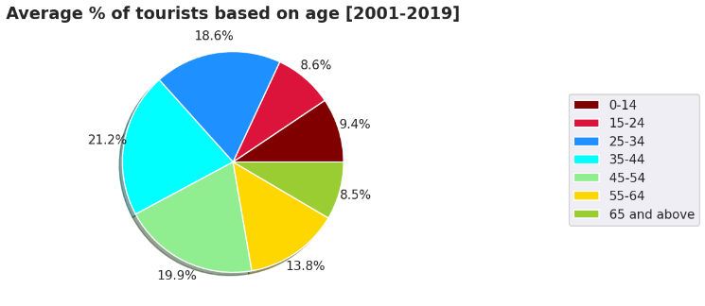**e. Policy Implications:**

* Recommendations included promoting lesser-known destinations in peak seasons to distribute tourist loads more evenly.

**VIII. Challenges and Limitations**

**a. Dimensionality vs. Interpretability:**

* While PCA reduced data dimensionality, the interpretability of individual components required additional effort.

**b. Clustering Sensitivity:**

* K-Means results depended on initial centroids and the chosen k.

**c. Incomplete Data:**

* Missing values in the 2020-21 datasets may have influenced temporal comparisons.

**IX. Tools and Libraries**

The study leveraged a robust data analysis pipeline built on Python:

**Libraries:**

1. pandas and numpy: Data manipulation and numerical computations.
2. sklearn: PCA, clustering, and evaluation metrics.
3. matplotlib and seaborn: Visualization.

**Development Environment:**

1. Google Colab for interactive exploration.
2. 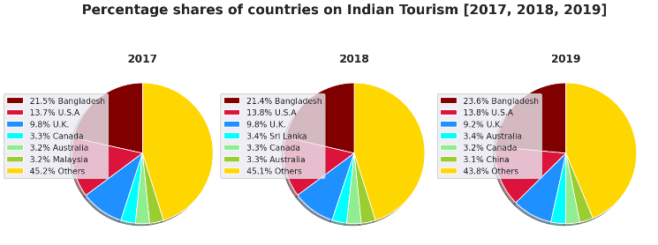**EXPERIMENTAL RESULTS**

**Fig. 2 - Percentage shares of countries on Indian Tourism [2017, 2018, 2019]**

Figure 2 illustrates the percentage share of countries in Indian tourism from 2017 to 2019. Bangladesh consistently leads, contributing over 21%, followed by the USA and UK with smaller shares. Other countries make up the majority, exceeding 45% annually, showcasing a diverse range of contributors. The data highlights stable trends in international tourism sources for India.

**Fig. 3 - Average % of tourists based on age [2001-2019]**

Figure 3 shows the average percentage of tourists by age group from 2001 to 2019. The largest share is from the 45 – 54 age group (21.2%), followed by 35 – 44 (19.9%) and 55–64 (18.6%), indicating a higher 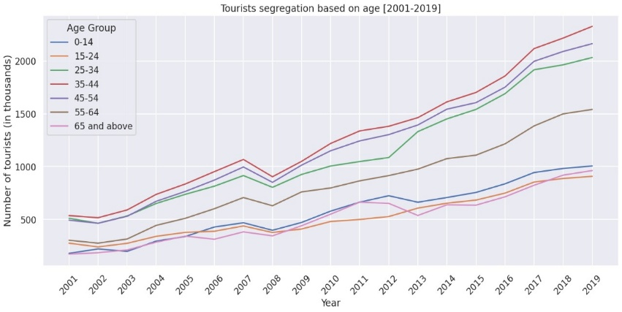participation of middle-aged and older adults. Younger age groups (0–34) collectively contribute less than half, 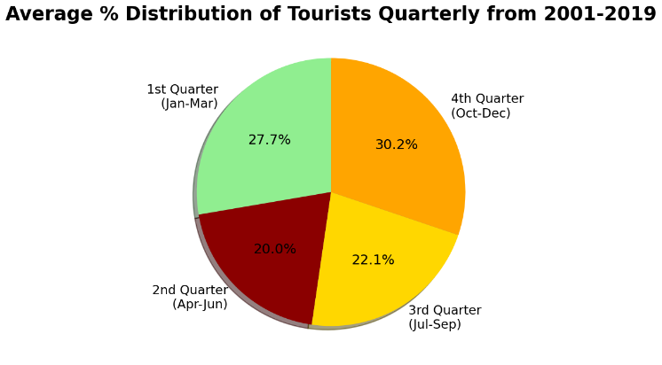highlighting tourism's appeal to older demographics.

**Fig. 4 - Average % Distribution of Tourists Quarterly from 2001-2019**

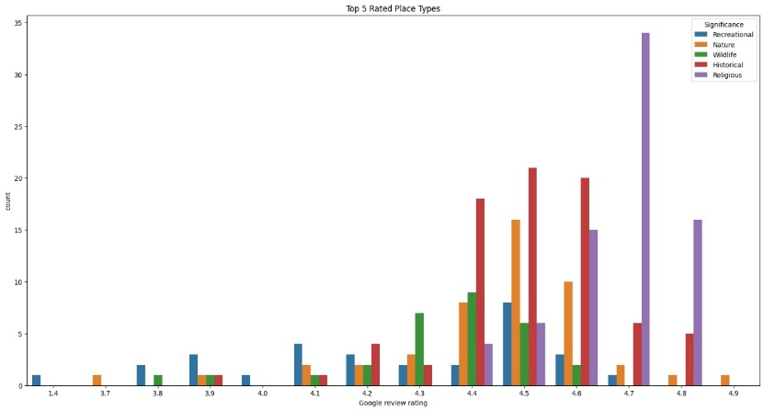Figure 4 illustrates the average percentage distribution of tourists across four quarters from 2001 to 2019. The highest percentage of tourists (30.2%) visited during the 4th quarter (October to December), followed by 27.7% in the 1st quarter (January to March). The 3rd quarter (July to September) accounted for 22.1% of tourist visits, while the 2nd quarter (April to June) had the lowest share at 20.0%. The chart highlights seasonal variations in tourist activities over the years.

**Fig. 5 - Top 5 Rated Place Types**

Figure 5 displays the top 5 rated place types based on Google review ratings. Categories include recreational, natural, historic, religious, and other places, with their counts distributed across ratings from 1.4 to 4.9. Religious places dominate higher ratings (4.7-4.9), while recreational and natural sites have a balanced spread, peaking around 4.5. Historic places exhibit a more even distribution with moderate counts, highlighting variations in how different place types are rated by visitors.

**Fig. 6 - Tourists segregation based on age [2001-2019]**

Figure 6 shows tourist segregation by age group from 2001 to 2019, measured in thousands. Across the years, all age groups exhibit a steady increase in tourist numbers, with a notable dip around 2009, likely due to global events. The 25-34 and 35-44 age groups consistently have the highest counts, while the 65 and above group shows gradual growth. The 0-14 group remains the lowest throughout, reflecting age-related travel preferences.

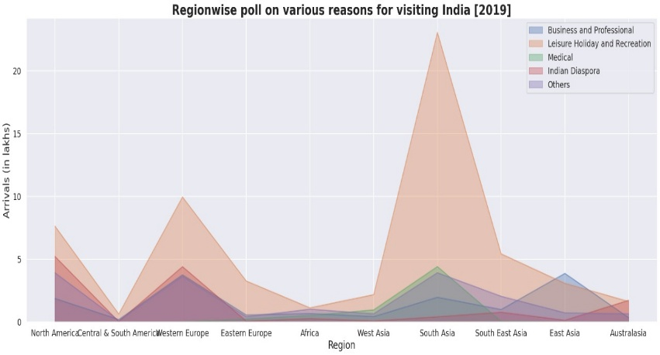

**Fig. 7 - Region wise poll on various reasons for visiting India [2019]**

Figure 7 shows region-wise arrivals to India in 2019, segmented by reasons for visiting. South Asia leads with the highest visitors, driven by Indian Diaspora and leisure tourism. Western Europe follows, contributing significantly to business and leisure trips. Other regions, like North America and Southeast Asia, show moderate arrivals, while medical tourism remains less prominent but visible in South and West Asia. Overall, the chart highlights India's strong pull for leisure and diaspora visits, with potential growth in medical tourism.

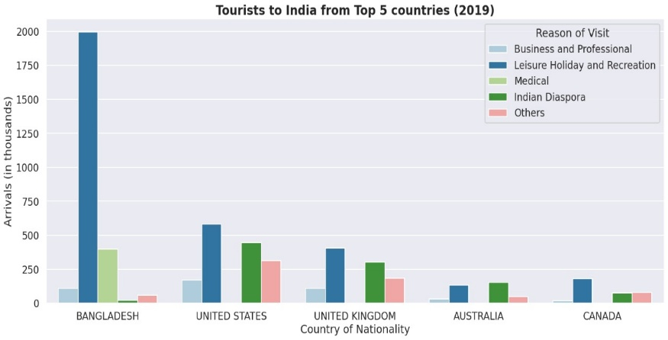**Fig. 8 - Tourists to India from Top 5 countries (2019)**

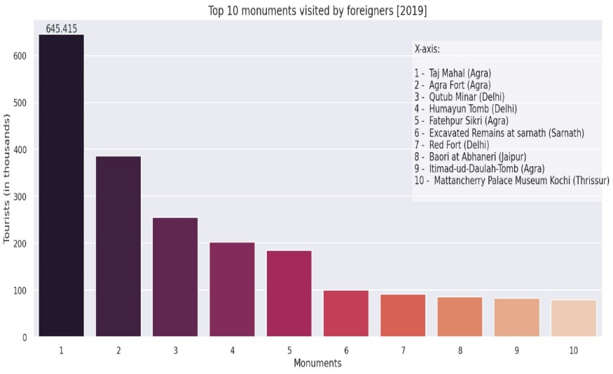Figure 8 highlights tourist arrivals to India from the top 5 countries in 2019. Bangladesh leads significantly, driven by leisure tourism and medical visits. The United States and the United Kingdom follow, with balanced contributions from business, leisure, and diaspora visits. Australia and Canada show lower but consistent tourist flows, primarily for leisure and diaspora purposes.

**Fig. 9 - Top 10 monuments visited by foreigners [2019]**

Figure 9 shows the top 10 monuments visited by foreign tourists in India in 2019. The Taj Mahal in Agra leads with over 645,000 visitors, followed by Agra Fort and Qutub Minar in Delhi. Other popular attractions include Humayun's Tomb, Fatehpur Sikri, and the Red Fort. The list highlights a strong preference for iconic historical and architectural sites, primarily concentrated in Agra, Delhi, and Jaipur.

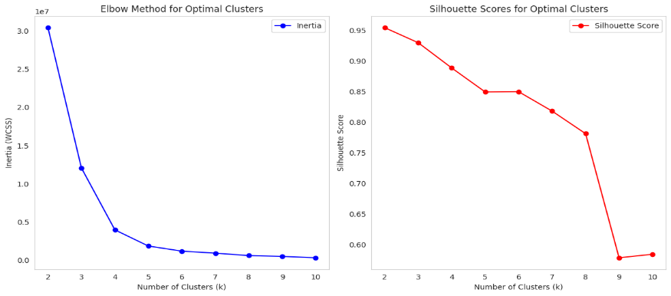

**Fig. 10 - Elbow Method for Optimal Clusters and Silhouette Scores for Optimal Clusters**

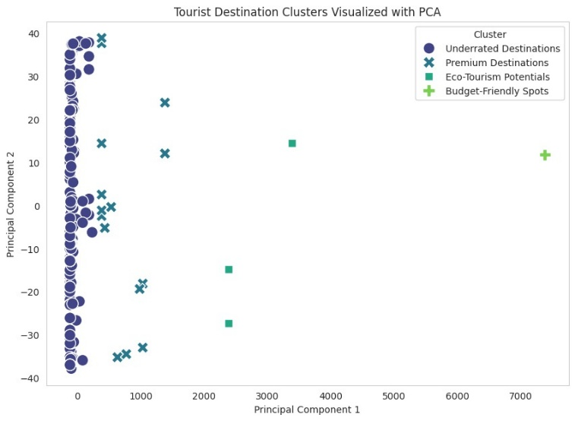Figure 10 uses two methods to determine the optimal number of clusters (k) for clustering analysis. In the **Elbow Method** (left plot), the inertia (WCSS) decreases sharply as k increases but levels off around k=4, indicating the optimal number of clusters where adding more clusters doesn’t significantly reduce WCSS. In the **Silhouette Score** (right plot), higher scores indicate better cluster cohesion and separation. The scores decrease as k increases, with the highest values at k=2 or 3, suggesting these clusters are more well-defined. Together, these methods help balance compactness and interpretability when selecting k.

**Fig. 11 - Tourist Destination Clusters Visualized with PCA**

Figure 11 visualizes clusters of tourist destinations using Principal Component Analysis (PCA) for dimensionality reduction. Four clusters are shown**: Underrated Destinations** (dense cluster near the origin), **Premium Destinations** (spread out, marked by crosses), **Eco-Tourism Potentials** (squares with moderate spread), and **Budget-Friendly Spots** (plus signs, further apart). PCA simplifies the data into two principal components, highlighting distinctions between clusters based on key features of the destinations.

**Fig. 12 - Distribution of Google Review Ratings Across Clusters (Original Scale)**

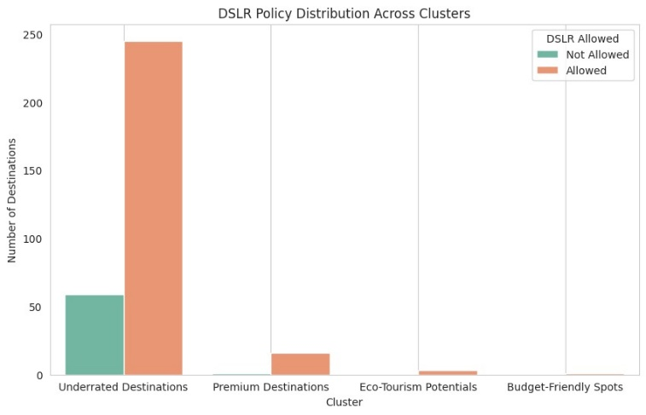Figure 12 compares the average Google Review ratings across four tourist destination clusters: Underrated Destinations, Premium Destinations, Eco-Tourism Potentials, and Budget-Friendly Spots. The highest ratings are observed for Budget-Friendly Spots, followed by Underrated Destinations and Eco-Tourism Potentials, while Premium Destinations have slightly lower average ratings. Error bars indicate the variability in ratings within each cluster.

**Fig. 13 - DSLR Policy Distribution Across Clusters**

Figure 13 presents the DSLR policy distribution across various clusters of tourist destinations. The "Underrated Destinations" cluster dominates with a high number of destinations allowing DSLR use, while a smaller fraction restricts it. In contrast, the other clusters ("Premium Destinations," "Eco-Tourism Potentials," and "Budget-Friendly Spots") show a minimal representation, with negligible destinations allowing or restricting DSLR usage. This indicates that DSLR policies are primarily relevant to the "Underrated Destinations" category.

1. 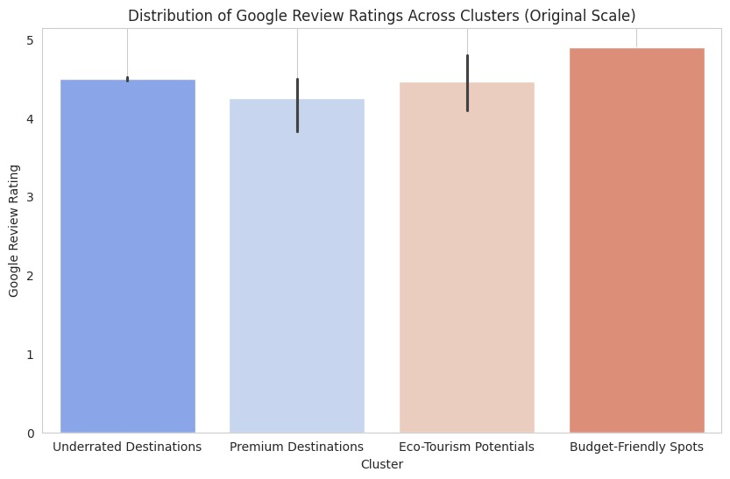**EXPERIMENTAL FINDINGS**

The findings of this study underscore the transformative potential of data-driven methodologies in understanding the complexities of Indian tourism. Through the integration of exploratory data analysis, Principal Component Analysis (PCA), and clustering techniques, this research provided insights into how destinations differ in their appeal, the preferences of visitors, and the impact of external factors such as the COVID-19 pandemic. The systematic approach not only highlighted the key factors driving tourism patterns but also demonstrated how advanced analytics can inform policy-making, marketing, and operational strategies in the tourism sector. At the core of this study is the recognition that tourism is a multi-dimensional domain influenced by a myriad of factors. The datasets analysed in this research spanned various aspects of Indian tourism, including state-wise attraction data, visitor demographics, and year-over-year trends in foreign and domestic tourist arrivals. Initial exploration of these datasets revealed several critical trends, such as the dominance of culturally significant and religious destinations, the popularity of winter months for travel, and the differential impacts of affordability on visitor preferences.

By structuring this information into meaningful categories, the study established a robust foundation for deeper analysis through PCA and clustering. One of the primary contributions of this research is the application of PCA to reduce the dimensionality of a complex dataset without significant loss of information. PCA revealed that visitor preferences are primarily influenced by factors like affordability (e.g., entrance fees) and visitor satisfaction (e.g., Google ratings). This simplification of data not only made clustering possible but also provided clarity on the major drivers of tourism behaviour. The temporal analysis of tourist arrivals revealed clear seasonal trends, with winter months (October to March) consistently attracting the highest numbers of visitors. This aligns with India's climatic conditions, where cooler months provide a more comfortable travel experience for both domestic and international tourists. However, this concentration of tourist activity poses challenges such as overcrowding, resource depletion, and environmental stress at popular destinations. The study suggests that promoting off-peak travel through discounts, events, and targeted marketing could alleviate these pressures while maintaining economic benefits.

The analysis also highlighted the severe impact of the COVID-19 pandemic on tourism. A year-over-year comparison between 2019 and 2020 showed significant declines in both foreign and domestic tourist arrivals, with international travel experiencing sharper reductions due to travel restrictions and global uncertainty. Domestic tourism, while also affected, showed relative resilience, suggesting that localized travel could be a key driver of recovery. States heavily reliant on international tourists, such as Tamil Nadu and Maharashtra, faced significant economic setbacks, underscoring the need for diversification in tourist demographics and offerings. The research provided valuable insights into the demographic composition and behavioural patterns of tourists. Analysis of age-group data revealed that the 25-34 and 35-44 age brackets dominate, reflecting the preferences of working-age individuals who are more likely to travel for leisure, cultural exploration, or professional purposes. Visitor behaviour was also analysed through attributes like the time required to visit attractions, DSLR camera permissions, and Google review ratings. Destinations with shorter visit durations and high ratings were found to be more popular, suggesting that accessibility and ease of exploration are critical factors. Similarly, the allowance of DSLRs was positively correlated with visitor interest, particularly for destinations with aesthetic or natural appeal.

These findings emphasize the importance of operational decisions, such as improving infrastructure, providing photography-friendly policies, and enhancing visitor experiences, to increase footfall and satisfaction. The COVID-19 pandemic posed unprecedented challenges to the tourism industry, and this study provides a data-driven perspective on its impact. The analysis of 2020 data revealed a drastic decline in foreign tourist arrivals, particularly in states with major international airports and globally renowned attractions. In contrast, states with strong domestic travel networks experienced a relatively milder impact, highlighting the importance of fostering domestic tourism as a buffer against global disruptions. Recovery strategies could include promoting domestic travel through campaigns that highlight the safety and affordability of local destinations. Hybrid travel experiences, such as virtual tours and online cultural events, could also help maintain international interest in Indian tourism until normal travel patterns resume. Furthermore, the clustering of destinations based on their resilience to the pandemic could inform targeted recovery plans, ensuring resources are allocated where they are most needed.

The findings of this research have wide-ranging implications for policymakers, businesses, and local communities. Policymakers can use the insights to prioritize investments in infrastructure, such as transportation networks and visitor facilities, in high-performing clusters. They can also implement sustainability initiatives to protect environmentally sensitive areas identified in the analysis. For businesses, the segmentation of destinations into distinct clusters provides a roadmap for developing customized travel packages and marketing strategies. Travel agencies, for instance, could design packages tailored to specific clusters, such as luxury cultural tours or budget**-**friendly adventure trips. The integration of exploratory data analysis, PCA, and clustering ensured a comprehensive approach to understanding tourism data. Each phase of the methodology addressed specific challenges, such as missing data, high dimensionality, and the need for actionable insights. PCA effectively reduced the complexity of the dataset, while clustering algorithms revealed patterns that were not immediately evident in the raw data. However, the study also faced certain limitations.

The temporal focus on specific years, particularly 2019 and 2020, restricted the scope of long-term trend analysis. Additionally, the clustering results, while insightful, may have oversimplified nuanced patterns, as K-Means clustering assumes spherical clusters and equal variance, which may not always hold true in real-world data. Future studies could address these limitations by incorporating hierarchical clustering or hybrid approaches that combine the strengths of multiple algorithms. While this research focuses on Indian tourism, its methodology and findings have broader implications for the global tourism industry. The use of PCA and clustering to analyse multi-dimensional data can be applied to other regions facing similar challenges, such as balancing growth with sustainability and adapting to disruptions like the COVID-19 pandemic. The insights into visitor behaviour, destination segmentation, and recovery strategies offer a replicable framework for stakeholders worldwide.

**Cluster Descriptions and Insights**

The project has categorized Indian tourist destinations into four clusters: Premium Destinations, Budget-Friendly Spots, Eco-Tourism Potentials, and Underrated Destinations. Each cluster represents distinct characteristics, target audiences, and development needs, offering valuable insights into the tourism landscape.

1. **Premium Destinations**

These destinations are well-established and cater to wealthy, high-paying tourists, including international travellers. They are characterized by high Google review ratings, reflecting visitor satisfaction, and higher entrance fees, indicating exclusivity. DSLR cameras are typically allowed, showing less restrictive policies, and the destinations often offer premium experiences such as luxury accommodations and guided tours. To maintain their appeal, these destinations can focus on enhancing high-end amenities, personalized services, and exclusive packages to continue attracting affluent visitors.

1. **Budget-Friendly Spots**

Budget-friendly destinations are known for their affordability and accessibility, making them ideal for families, students, and large groups. These spots are characterized by low entrance fees and moderate Google review ratings, indicating decent satisfaction levels but room for improvement. Developing basic infrastructure and promoting family-friendly activities would enhance their appeal. Cost-effective promotional strategies can also help these destinations gain more visibility among their target audience.

1. **Eco-Tourism Potentials**

Eco-tourism destinations hold significant natural or ecological importance, appealing to eco-conscious travellers. These spots often have moderate entrance fees, which are typically used for conservation efforts. While they have high to moderate Google review ratings, DSLR restrictions may be in place to protect the environment. Developing eco-friendly infrastructure, such as nature trails and sustainable accommodations, can enhance their appeal. Additionally, targeted campaigns that highlight the ecological significance and sustainability of these destinations can attract environmentally aware tourists.

1. **Underrated Destinations**

This cluster consists of lesser-known and unexplored destinations with untapped potential. These destinations often have minimal or no entrance fees and lower Google review ratings, which could be attributed to a lack of awareness or inadequate infrastructure. However, they offer significant opportunities for development. Improving accessibility, infrastructure, and amenities, combined with targeted marketing efforts, can transform these destinations into attractive tourist spots. Collaborating with local communities and leveraging social media influencers can further boost their visibility and reputation.

**Comparative Analysis of Clusters**

When comparing the clusters, Premium Destinations stand out with the highest Google review ratings and entrance fees, targeting affluent tourists. Budget-Friendly Spots, in contrast, attract cost-conscious travellers with low fees and moderate ratings. Eco-Tourism Potentials offer a niche appeal to eco-conscious individuals, with fees often tied to conservation efforts. Underrated Destinations, though lagging in ratings and development, hold immense potential for growth with the right investments in infrastructure and promotion.

The clusters also vary in terms of DSLR policies and tourism potential. Premium and eco-tourism destinations are more DSLR-friendly, emphasizing their scenic and cultural significance. Meanwhile, underrated destinations need awareness campaigns to build their reputation and attract visitors. Each cluster represents a unique segment of the tourism market, providing actionable insights to tailor strategies for growth.

1. **DISCUSSION AND FUTURE WORK**

The findings of this proposal, "Tourism Data Exploration: Analysis and Visualization for Impactful Insights," demonstrate the transformative potential of Artificial Intelligence (AI) and Machine Learning (ML) in revolutionizing tourism management. By leveraging clustering algorithms, predictive modelling, and data visualization techniques, the study provides actionable insights into tourist preferences, resource optimization, and sustainable practices. However, the results also highlight limitations that pave the way for further advancements. The clustering algorithms, particularly K-Means, effectively segmented tourist destinations based on characteristics such as visitor ratings, entrance fees, and time requirements.

These clusters provide actionable insights for stakeholders, enabling targeted marketing strategies and efficient resource allocation. Predictive modelling using Random Forest demonstrated accurate forecasting of destination popularity and visitor trends, empowering tourism authorities to design informed strategies. The visual tools developed, such as pie chart and scatter plots, successfully bridged the gap between complex data and practical decision-making, making findings accessible to non-technical stakeholders. Despite these successes, challenges remain. The reliance on historical and structured datasets limits real-time adaptability, making it difficult to respond to dynamic changes such as shifts in traveller preferences during global events. Additionally, the computational demands of the models pose scalability challenges, especially for resource-constrained environments. Addressing privacy concerns, particularly when integrating social media data, is also critical to ensure compliance with ethical standards and data protection regulations.

This would enable stakeholders to make dynamic decisions, such as adjusting marketing strategies based on trending destinations or managing tourist inflow during crises. Advanced ML techniques, such as deep learning models like Recurrent Neural Networks (RNNs) or Transformer models, could further improve the accuracy of forecasting seasonal trends and dynamic behaviours. Expanding the scope to include global datasets would allow for cross-country comparisons and insights into universal tourism trends. Incorporating diverse datasets can also shed light on the impact of global phenomena, such as climate change, on tourism patterns. Multilingual capabilities and culturally sensitive recommendation systems could cater to a broader audience, making the models applicable to international travellers. Sustainability remains a key focus for future development. Integrating environmental impact metrics, such as carbon footprint calculations and recommendations for eco-friendly practices, can promote sustainable tourism. Encouraging balanced tourism by identifying underexplored regions can help alleviate the pressure on overburdened destinations. Emerging technologies like Augmented Reality (AR) and Virtual Reality (VR) can also enhance the travel planning experience, offering virtual tours and simulations to guide user decisions. Collaboration with tourism boards, travel agencies, and local businesses is essential for validating and implementing these models in real-world scenarios. Partnerships can facilitate access to diverse datasets, provide industry feedback, and ensure practical applicability. Additionally, incorporating crisis management systems, such as predictive tools for natural disasters or pandemics, could make the tourism sector more resilient. In conclusion, this proposal has successfully demonstrated the utility of AI and ML in addressing challenges in the tourism sector while laying the foundation for future advancements. By integrating real-time data, advanced analytics, sustainability metrics, and emerging technologies, future research can create a robust, inclusive, and sustainable tourism ecosystem, ensuring long-term growth and enriched traveller experiences.

1. **CONCLUSION**

In conclusion, this research demonstrates the transformative potential of data-driven methodologies in understanding and optimizing tourism. By combining advanced analytics with domain-specific insights, the study provides a comprehensive framework for analysing complex datasets and deriving actionable insights. The findings highlight the importance of affordability, visitor satisfaction, and seasonal trends in shaping tourism patterns, while the clustering of destinations into distinct groups offers a roadmap for targeted strategies. As the tourism industry continues to evolve, this research underscores the need for innovation, adaptability, and a focus on sustainability to navigate future challenges and opportunities effectively.

**VIII. REFERENCES**

[1]. J. Wu, J. Pierse, F. Orlandi, D. O'Sullivan and S. Dev, "Improving Tourism Analytics from Climate Data Using Knowledge Graphs," in IEEE Journal of Selected Topics in Applied Earth Observations and Remote Sensing, vol. 16, pp. 2402-2412, 2023, doi: 10.1109/JSTARS.2023.3239831.

[2]. O. Alcaraz, A. Berenguer, D. Tomás, M. A. Celdrán-Bernabeu and J. -N. Mazón, "Augmenting Retail Data with Open Data for Smarter Tourism Destinations," in IEEE Access, vol. 12, pp. 153154-153170, 2024, doi: 10.1109/ACCESS.2024.3480326.

[3]. S. Forouzandeh, M. Rostami and K. Berahmand, "A Hybrid Method for Recommendation Systems based on Tourism with an Evolutionary Algorithm and Topsis Model," in Fuzzy Information and Engineering, vol. 14, no. 1, pp. 26-50, March 2022, doi: 10.1080/16168658.2021.2019430.

[4]. T. Peng, J. Chen, C. Wang and Y. Cao, "A Forecast Model of Tourism Demand Driven by Social Network Data," in IEEE Access, vol. 9, pp. 109488-109496, 2021, doi: 10.1109/ACCESS.2021.3102616

[5]. İ. Topal and M. K. Uçar, "Hybrid Artificial Intelligence Based Automatic Determination of Travel Preferences of Chinese Tourists," in IEEE Access, vol. 7, pp. 162530-162548, 2019, doi: 10.1109/ACCESS.2019.2947712.

[6]. Ahmed, Nesreen & Gayar, Neamat & El-Shishiny, Hisham, “Tourism Demand Forecasting using Machine Learning Methods”, 2007.

[7]. Ram Krishn Mishra, Siddhaling Urolagin, J. Angel Arul Jothi, Nishad Nawaz and Haywantee Ramkissoon, “Machine Learning based Forecasting Systems for Worldwide International Tourists Arrival” International Journal of Advanced Computer Science and Applications(IJACSA), 12(11), 2021, 10.14569/IJACSA.2021.0121107

[8]. Noelyn M. De Jesus and Benjie R. Samonte, “AI in Tourism: Leveraging Machine Learning in Predicting Tourist Arrivals in Philippines using Artificial Neural Network” International Journal of Advanced Computer Science and Applications(IJACSA), 14(3), 2023, 10.14569/IJACSA.2023.0140393

[9]. Bilal sultan Abdualgalil and Sajimon Abraham, “Tourist Prediction Using Machine Learning Algorithms”, 2020.

[10]. Dinda Thalia Andariesta, Meditya Wasesa, “Machine learning models for predicting international tourist arrivals in Indonesia during the COVID-19 pandemic: a multisource Internet data approach”, Journal of Tourism Futures, 2022, doi: 10.1108/JTF-10-2021-0239.

[11]. L. C. Gonzalez and G. R. Restrepo, "Improving Tourism Forecasting Accuracy with Deep Learning Models: A Comparative Study," in International Journal of Forecasting, vol. 38, no. 1, pp. 45-60, 2022, doi: 10.1016/j.ijforecast.2021.08.006.

[12]. S. S. Makridakis, R. P. Vassiliadis, and N. I. Papadopoulos, "Artificial Intelligence for Smart Tourism: A Data-Driven Perspective," in Tourism Management, vol. 90, pp. 104501, 2023, doi: 10.1016/j.tourman.2022.104501.

[13]. A. Li, X. Zhang, and Q. Liu, "Predicting Tourist Flows Using Social Media and IoT Data: An AI-Based Approach," in IEEE Transactions on Computational Social Systems, vol. 10, no. 2, pp. 473-485, 2023, doi: 10.1109/TCSS.2023.3263725.

[14]. M. Y. Yilmaz and H. K. Çolak, "Tourism Demand Prediction with Hybrid Machine Learning Models during Crisis Periods: Case of COVID-19," in Expert Systems with Applications, vol. 206, 2022, doi: 10.1016/j.eswa.2022.117888.

[15]. T. C. Nguyen and J. Lee, "Enhancing Tourism Analytics Using Knowledge Graphs and Sentiment Analysis," in Big Data and Cognitive Computing, vol. 6, no. 2, 2022, doi: 10.3390/bdcc6020018.

[16]. S. Chen, K. D. Lee, and M. Rajan, "Integrating Climate and Economic Factors for Tourism Demand Forecasting Using Deep Neural Networks," in Environmental Modelling & Software, vol. 157, 2023, doi: 10.1016/j.envsoft.2022.105575.

[17]. Y. Wang, L. Guo, and X. Fang, "The Application of Generative AI Models for Personalized Tourism Recommendations," in ACM Transactions on Intelligent Systems and Technology, vol. 14, no. 3, pp. 1-19, 2023, doi: 10.1145/3579126.

[18]. F. M. Zhang and T. S. Huang, "AI-Driven Predictive Systems for Tourism Recovery in Post Pandemic Scenarios," in Journal of Hospitality and Tourism Technology, vol. 14, no. 1, 2023, doi: 10.1108/JHTT-05-2022-0107.

[19]. M. E. Rahman, F. Rahman, and T. Hossain, "Impact of Big Data Analytics and Machine Learning in Predicting Tourism Trends," in International Journal of Data Science and Analytics, vol. 14, no. 4, 2023, doi: 10.1007/s41060-023-00387-2.

[20]. C. Torres-Sanz and I. Amat, "Smart Tourism and AI: Improving Destination Management with Predictive Analytics," in Journal of Destination Marketing & Management, vol. 29, 2023, doi: 10.1016/j.jdmm.2023.100777.